

**<<F-Gear>>**

**Software Requirement Specification**

– Ho Chi Minh, September 2021 –

**Table of Contents**

I. Overview 3

1. Introduction 3

2. System Functions 4

3. Common Requirements 5

II. Functional Requirements 6

1. <<Feature Name 1>> 6

a. <<Function Name 1>> 6

b. <<Function Name 2>> 6

2. <<Feature Name 2>> 6

# I. Overview

## 1. Introduction

*It is a web application that makes it easy for people who need to buy computer equipment or laptops to access their preferences and find what they like the most. With a simple and elegant interface that is easy to navigate and use, this web application always puts user experience first and is suitable for users aged 12 and over. The web application also integrates the ability to log in through Google and pay online.*

*[Content part 2: describes the product's context in the form of a context diagram in which you present the boundary and connections between the system you’re developing and everything else in the universe. This identifies external entities (or terminators – software, hardware, human components, and other systems) outside the system that interface to it in some way, as well as data, control, and material flows between the terminators and the system]*

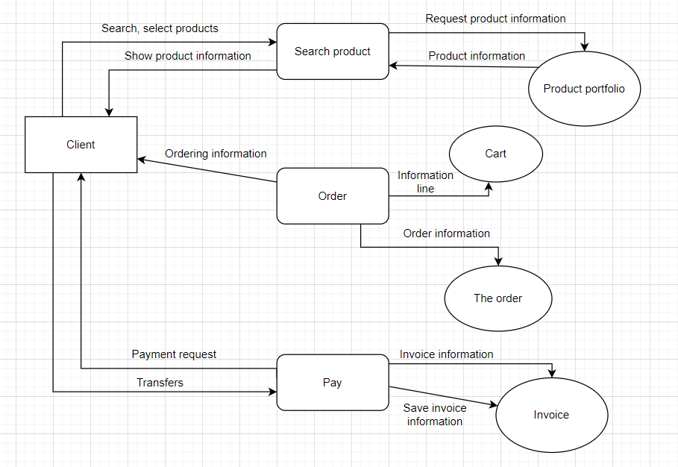>>

## 2. System Functions

#### a. Screen Flow

*[This part shows the system screens and the relationship among screens. You can draw the Screens Flow for the system in the form of diagram as below]*

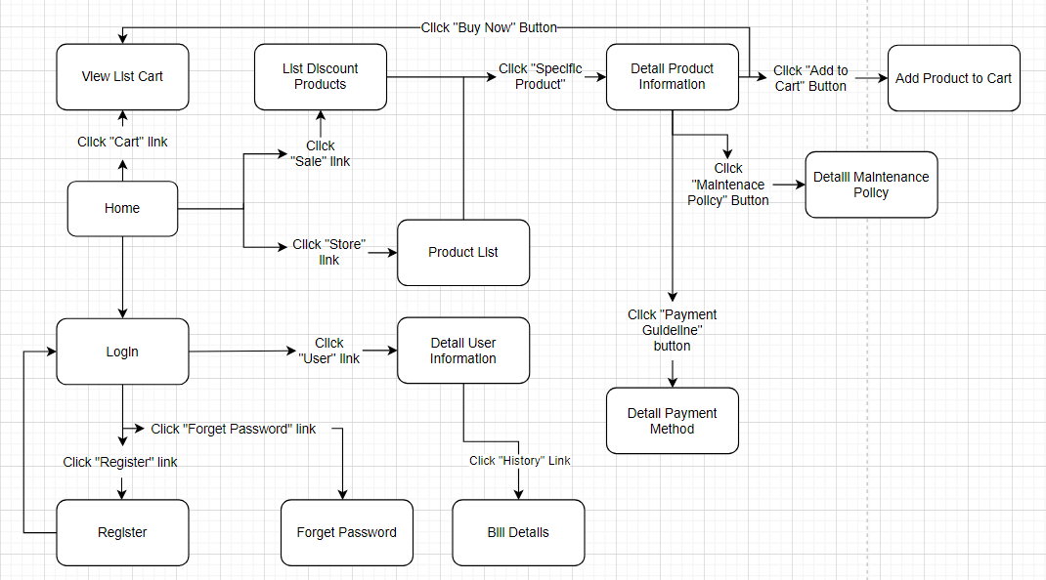

#### b. Screen Details

*[Provide the descriptions for the screens in the Screens Flow above]*

|  |  |  |  |
| --- | --- | --- | --- |
| **#** | **Feature** | **Screen** | **Description** |
| 1 | Login function for customer and administrator. |  | This screen displays a form with a username and password, or can login with "Login with Google" button. If customer don`t have an account, they can sign in or if forget the password, they also can get a new password. |
| 2 | Register function |  | You can sign up for a new account if this is your first time using a web application that you don't want to log in with a Google account. |
| 3 | Display all products you added to your cart. |  | Show all products that you have added to the shopping cart, on this screen will also display the total amount to pay, the number of items in the basket, and the buttons to delete each product or modify the number of products. Of course, there are basic buttons such as payment, clearing the shopping cart. |
| 4 | Display different products with all brands. |  | There's a lot of products that come from different brands, or you can choose any brand to find the products that come from that brand. |
| 5 | Display all products we discounted in our web app |  | With our customers' hunting needs on sale, we always have tremendous promotions for our customers at "Sale" |
| 6 | Show detailed information about bills | Bill Details Screen | Display the item view list when the customer wants to review it |
| 7 | Show all information about a product |  | So that customers can understand information about products, as well as product quality. We always show all the information about the product to make it easy for customers to grasp |
| 8 | Show detailed maintenance policy | Detail maintenance policy Screen | so that the customer understands the product's maintenance policies, so that the customer can take the initiative in exchanging the product if there is a technical error. |
| 9 | Show how to pay for a shopping cart |  | to show the payment policy clearly |
| 10 | Show all information about your account |  | Display information about a customer's account, which can change some of the information as the customer wishes |

#### c. User Authorization

*[Provide the system roles authorization to the system features (down to screens, and event to the screen activities if applicable) in the table form as below – replace Role1, Role2,… with the specific system user role names]*

|  |  |  |
| --- | --- | --- |
| **Screen** | **Role 1: Administrator** | **Role 2: Customers** |
| Login | X | X |
| Get New Password |  | X |
| Register |  | X |
| Buy Products |  | X |
| Cart |  | X |
| Account Information | X | X |
| Change Information of Account | X | X |
| Change Discount | X |  |
| Query All Data | X |  |
| Query Own Data | X |  |
| Query Managed Data | X |  |
| Add New Data | X |  |
| Update All Data | X |  |
| Update Own Data | X |  |
| Update Managed Data | X |  |
| Delete Data | X |  |

In which:

* Role1: This is an account for web application administrators, with access to data, customer accounts, and some customer information.
* Role2: This is an account for customers who want to buy products or are interested in our web application, which is available for purchase, payment or some basic rights for customers on the online shopping platform

#### d. Non-Screen Functions

*[Provide the descriptions for the non-screen system functions, i.e batch/cron job, service, API, etc.]*

|  |  |  |  |
| --- | --- | --- | --- |
| **#** | **Feature** | **System Function** | **Description** |
| 1 | Validation account information | Validation | To ensure that customers have accounts that meet community standards and are easy to manage |
| 2 | Product status notification | Provide information | Notify users whether the product is in stock or not |
| 3 | Notice of order status | Provide information | Help users know whether the order has been successful or failed |

## 3. Common Requirements

-Users can check order history.

-Users can update their information.

-User can see detailed information about a product.

-Admin can CRUD product.

# II. Functional Requirements

## 1. <<Feature Name 1>>

### a. <<Function Name 1>>

*[A function can be a screen or a non-screen function (listed in the part 5.1 above). In this part, you need to provide the details on the related function, focus on mentioning below information*

* *Function trigger: Click button login.*
* *Function description: Login to purchase products.*
* *Screen layout: mockup prototype of the screen, sample below is for Manage Products screen*

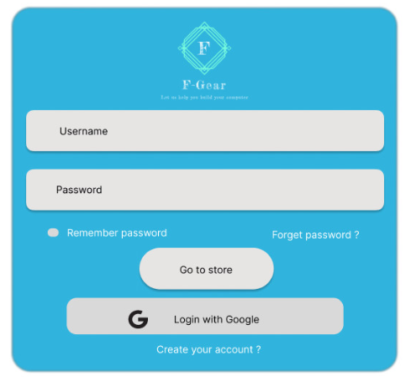

* *Function Details: provide explanation for the data, validation, business logics, functionalities (for both normal cases and abnormal cases), etc. of the function so that the reader can image how it work.*

*]*

### b. <<Function Name 2>>

…

## 2. <<Feature Name 2>>

…